**10.9 Equations of Circles on the Coordinate Plane**

**Level 1:**

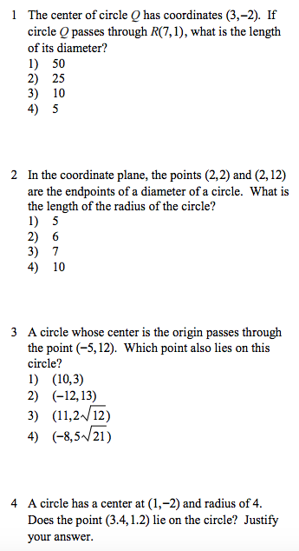

Graph the circle. What is the equation of this circle? Graph the circle. What is the equation of this circle?

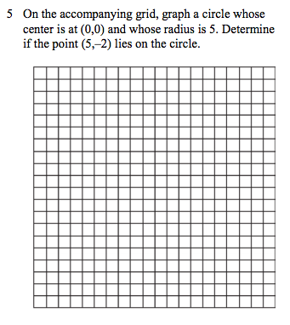 





Graph this circle. What is the equation of this circle?



**Level 2:***For all 5 problems, write down the A, B, C, and D value that you plug into your calculator* ***before*** *finding center and radius.*

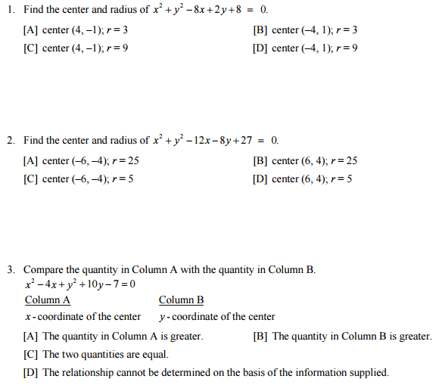

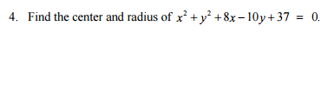

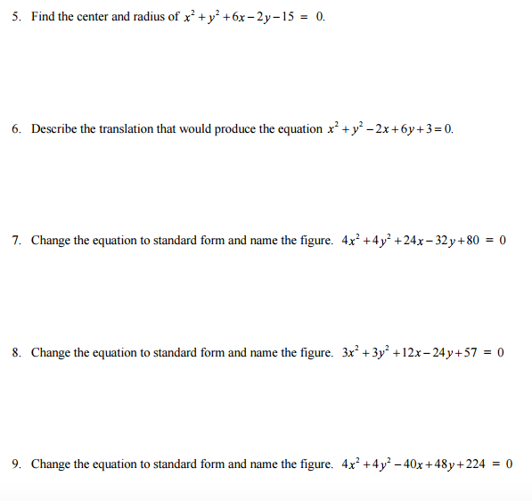

**Level 3:**

